Installation of CentOS with Virtual Box / CANTERA_AVBP / ARCANE
Installation tested for CentOS 7, CentOS 8.
To get CentOS : https://www.centos.org/
To get Virtual Box : Oracle VM VirtualBox

Set the Linux environment
Many tutorials are available on the web to succeed at installing CentOS :
Base sur le début d’installation :
https://laptop.ninja/how-to-setup-centos-in-virtualbox/
Le plus complet :
https://www.youtube.com/watch?v=UrNe0_rW9qY&list=LLxBjKjxH2Hs3k0mJwAdaUeA&index=10
Complémentaire :
https://www.youtube.com/watch?v=31Xfju-yCHw&list=LLxBjKjxH2Hs3k0mJwAdaUeA&index=12&t=555s

- Machine > Create
  - Name your environment: Specify the path for the virtual machine
  - Memory size: Allow some RAM (depends on your computer specs)
  - Hard Disk: Create a virtual hard disk now
  - Hard Disk file type: VDI (Virtual Disk Image)
  - Storage on physical hard disk: Dynamically allocated (then, allow some ROM)
- Settings
  - Storage: Empty IDE > Select a disk file .. (choose the CentOS ISO downloaded)
  - System: Pointing Device > Select USB tablet
- Start the environment
  - Select language
  - Installation Destination: click done since ROM is already allocated
  - User Settings: set a password
  - Start installation
  - Reboot
  - IF boot loop, go to storage > change boot order (first : hard drive, disk, floppy disk)
  - While the machine is down, settings > Display > Video memory to the max (128 Mb)
- Start again the environment
  - Configure it (user, password..)

Now we use a terminal in the freshly installed environment, but in a small window so let’s make it fullscreen:
- Check is the internet connection is enabled! (it sets itself off every restart)
If you are not able to connect to internet: https://www.youtube.com/watch?v=UUkCys309xA&list=LLxBjKjxH2Hs3k0mJwAdaUeA&index=11&t=127s
- Here is a list of commands to finish the installation of CentOS :
sudo yum update kernel*
sudo yum -y install gcc
sudo yum install make perl
sudo yum -y install kernel-devel-$(uname -r)
You might need to reboot CentOS if the previous command fails
sudo yum install elfutils-libelf-devel

From the guest file explorer, unmount the disk “VBox_Gas_...”
From the top panel > Devices > Insert Guest Additions CD Image.. > Run with password
Reboot the OS
Now you should be able to go fullscreen from top panel > View > Fullscreen !

Create a shared folder
The idea is to be able to communicate files between host OS and guest OS.
- Create a folder in the host file explorer, copy the path
- In the Virtual BOX manager
    - Settings > Advanced > Select bi-directional for both
    - In shared folder > Add folder > paste the path, select Auto-mount
  - 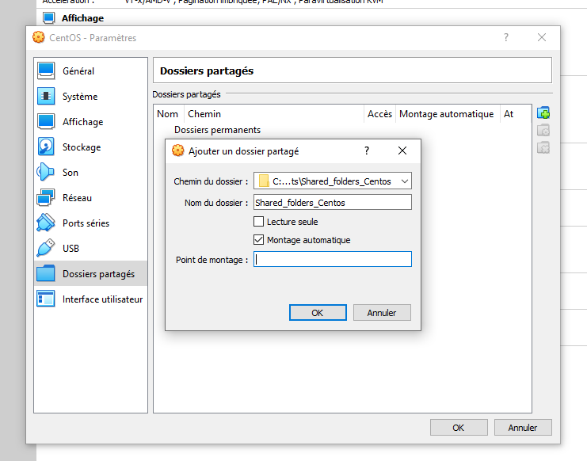
- In the terminal
    - Give yourself some rights:
sudo usermod -aG vboxsf yourusername
- Reboot !

CANTERA and ARCANE (requirements + git clone)
sudo yum install gcc-c++
sudo yum install gcc-gfortran
sudo yum update -y
Now let’s get Python (+Pip) installed:
Python3.7 (https://tecadmin.net/install-python-3-7-on-centos/ Be careful ! Python 3.6 won’t work with CANTERA. You can do the installation from sources with https://www.liquidweb.com/kb/how-to-install-python-3-on-centos-7/ )
DO NOT USE ALTINSTALL but INSTALL so Python3 is in the default directory usr/bin/python3
Here are the commands used:
yum install gcc openssl-devel bzip2-devel libffi-devel zlib-devel
cd /opt
wget https://www.python.org/ftp/python/3.7.9/Python-3.7.9.tgz
tar xzf Python-3.7.9.tgz
cd Python-3.7.9
./configure --enable-optimizations
make install
rm /usr/src/Python-3.7.9.tgz
python3.7 -V
This should return Python 3.7.9

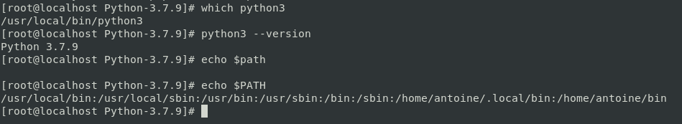
Python3.7 is installed in usr/local/bin but it’s ok since the python path is in PATH (picture above), the installation can be continued !
Now we must install other libraries to work with python:
Pip3 install Cython
Pip3 install Numpy
Pip3 install Matplotlib
Pip3 install pyqt5
Then you must download “boost”, put in in desktop and extract it here. Only its path matters for next installations.
cd Desktop
wget https://dl.bintray.com/boostorg/release/1.65.1/source/boost_1_65_1.tar.gz
tar -xvf boost_1_65_1.tar.gz
pwd
Keep the path close to you since it is needed for cantera.
sudo yum install git
sudo yum install emacs
pip3 install scons
pip3 install scipy
pip3 install networkx
cd Desktop
git clone https://gitlab.com/cerfacs/chemistry/cantera-avbp.git
(https://gitlab.com/cerfacs/chemistry/cantera-avbp)
cd cantera-avbp
emacs cantera.conf
In this config file: paste the path of “boost”
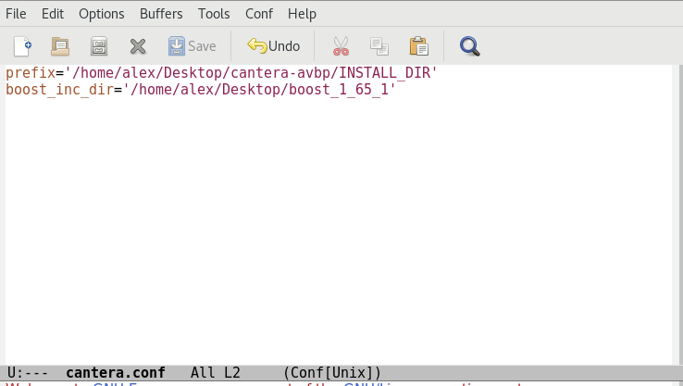
scons build (if fails, use scons clean and check previous steps..)
scons install
From scons install, a path to load the CANTERA environment is given, copy it.
CANTERA is installed, congrats!

- Now we make sure Cantera is loaded each time you open a terminal :
If emacs is installed:
emacs ~/.bashrc
otherwise: vi ~/.bashrc
Write the following source:
#CANTERA AVBP
source /home/xxxx/Desktop/cantera-avbp/INSTALL_DIR/bin/setup_cantera
(the path from scons install)

- To get ARCANE, you do a git clone as for CANTERA

- Test your freshly installed Cantera ! : https://cantera.org/examples/python/

